Tên: Đoàn Thanh Nam file đề:

Mssv: 20146506

BÀI TẬP ROBOT

Câu 1: 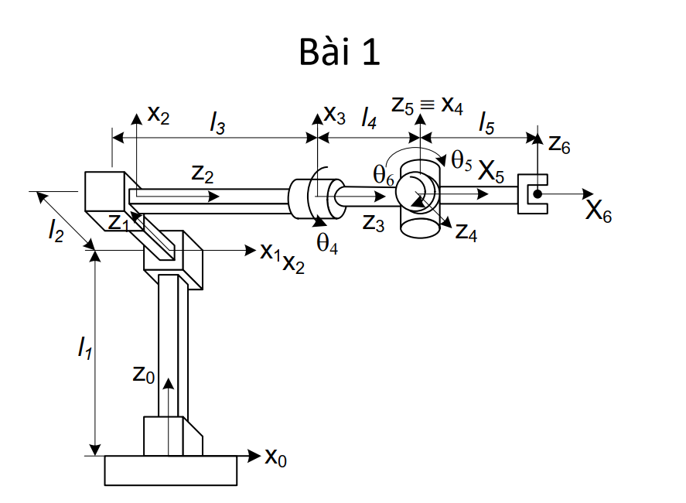

Mô Tả: T(l3,l2,l1)R(x,t4)T(l4,0,0)R(y,t6)R(z,t5)T(l5,0,0)

File: 

syms t4 t5 t6 pi;

l1=30; l2=20; l3=30; l4=10; l5=15;

for t4=0:0.1:pi/2

for t5=0:0.1:pi/2

for t6=0:0.1:pi/2

x = l3 + l4 + l5\*cos(t5)\*(cos(t6) - sin(t6));

y = l2 + l5\*(cos(t4)\*sin(t5) + cos(t5)\*sin(t4)\*sin(t6));

z = l1 + l5\*(sin(t4)\*sin(t5) - cos(t4)\*cos(t5)\*sin(t6));

plot3(x,y,z,'\*');

hold on

end

end

end

Câu 2: 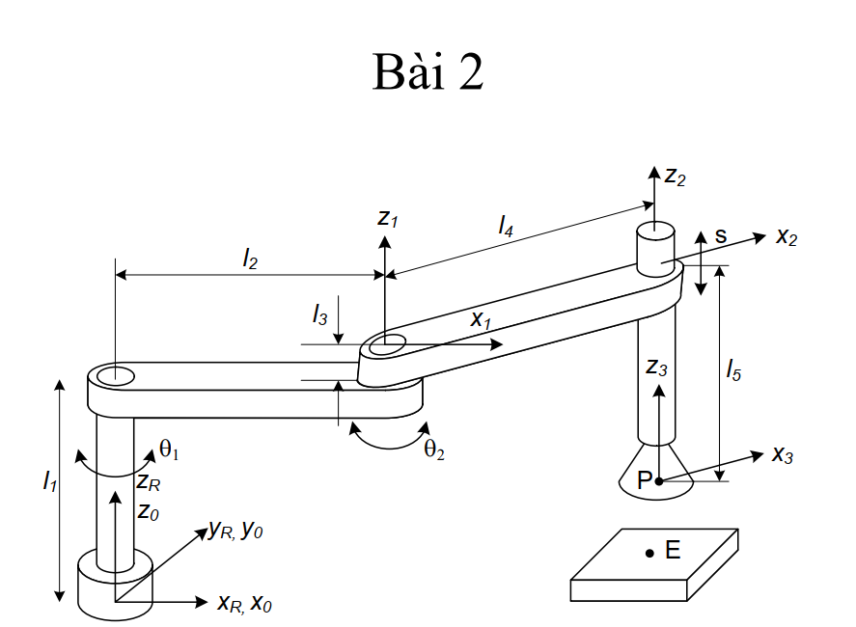

Mô tả:T(0,0,l1)R(z,t1)T(l2,0,0)R(z,t2)T(l4,0,l3-l5)

File: 

syms t1 t2 pi;

l1=40; l2=52; l3=8; l4=32; l5=20; s=5;

for t1=0:0.1:pi

for t2=0:0.1:pI

x= l4\*cos(t1 + t2) + l2\*cos(t1);

y= l4\*sin(t1 + t2) + l2\*sin(t1);

z= l1 + l3 - l5 + s;

plot3(x,y,z,'\*');

hold on

end

end

Câu 3: 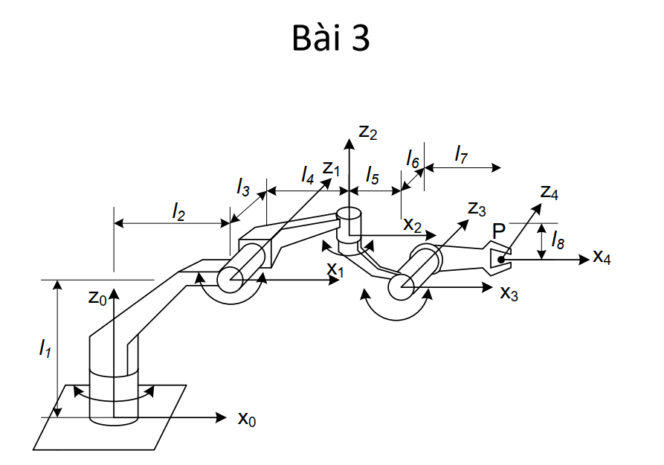

Mô tả:T(l2,0,l1)R(y,t1)T(0,l3,0)R(y,-t2)T(l4,0,0)R(z,t3)T(l5,-l8,0)R(y,t4)T(l7,l6,0)

File: 

syms t1 t2 t3 t4 pi;

l1=100; l2=65; l3=30; l4=35; l5=23; l6=9; l7=18; l8=12; s=6;

for t1=0:0.1:pi/2

for t2=0:0.1:pi

for t3=0:0.1:pi/2

for t4=0:0.1:pi

x= l2 + l4\*cos(t1 - t2) - l7\*sin(t1 - t2)\*sin(t4) + l5\*cos(t1 - t2)\*cos(t3) - l6\*cos(t1 - t2)\*sin(t3) + l8\*cos(t1 - t2)\*sin(t3) + l7\*cos(t1 - t2)\*cos(t4)\*cos(t3);

y= l3 + l6\*cos(t3) - l8\*cos(t3) + l5\*sin(t3) + l7\*cos(4)\*sin(t3);

z= l1 + l4\*sin(t1 - t2) + l7\*cos(t1 - t2)\*sin(t4) + l5\*sin(t1 - t2)\*cos(t3) - l6\*sin(t1 - t2)\*sin(t3) + l8\*sin(t1 - t2)\*sin(t3) + l7\*sin(t1 - t2)\*cos(t4)\*cos(t3);

plot3(x,y,z,'\*');

hold on

end

end

end

end

Câu 4: 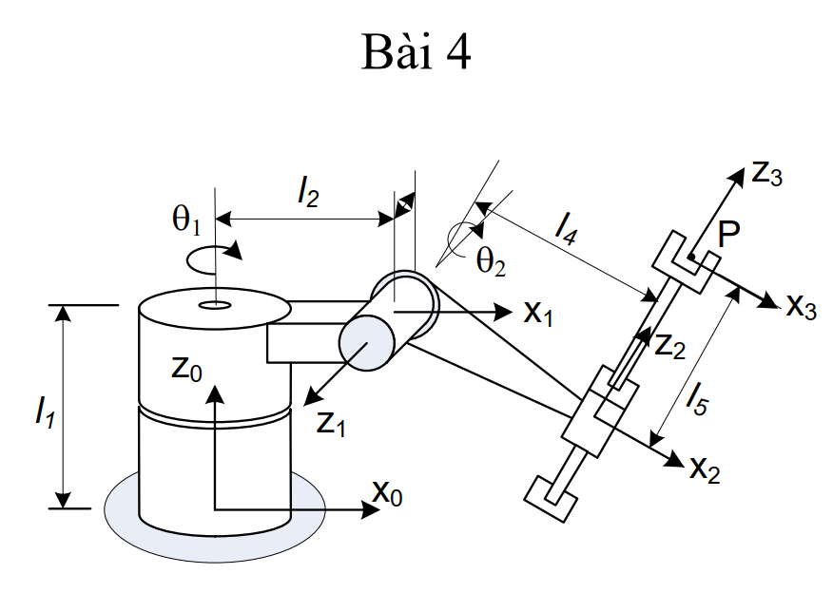

Mô tả: T(z, l1)R(z, -t1)T(x, l2)R(x, 90)T(z, -l3)R(z, -t2) T(x, l4)R(x, -90)T(z, l5)

File: 

syms t1 t2 pi;

l1=20; l2=6; l3=12; l4=12; l5=5; l6=8;

for t1=0:0.1:pi/2

for t2=0:0.1:pi

Px = l2\*cos(t1) + l3\*sin(t1) + l4\*cos(t1)\*cos(t2) + l5\*cos(t1)\*sin(t2);

Py = l3\*cos(t1) - l2\*sin(t1) - l4\*cos(t2)\*sin(t1) - l5\*sin(t1)\*sin(t2);

Pz = l1 + l5\*cos(t2) - l4\*sin(t2);

plot3(Px,Py,Pz,'\*');

hold on

end

end

Câu 5: 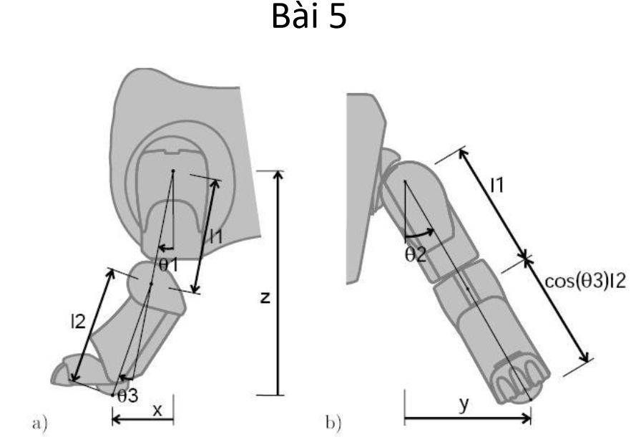

Mô tả:R(y,t1)R(x,t2)T(0,0,l1) R(y,t3)T(0,0,l2)

File:

syms t1 t2 t3 pi;

l1=20;l2=25;

for t1=0:0.2:pi

for t2=0:0.1:pi

for t3=0:0.1:pi/2

Px=l2\*sin(t1+t3)+l1\*sin(t1);

Py= -sin(t2)\*(l2\*cos(t1 + t3) + l1\*cos(t1));

Pz= cos(t2)\*(l2\*cos(t1 + t3) + l1\*cos(t1));

plot3(Px,Py,Pz,'\*')

hold on

end

end

end

Câu 6: 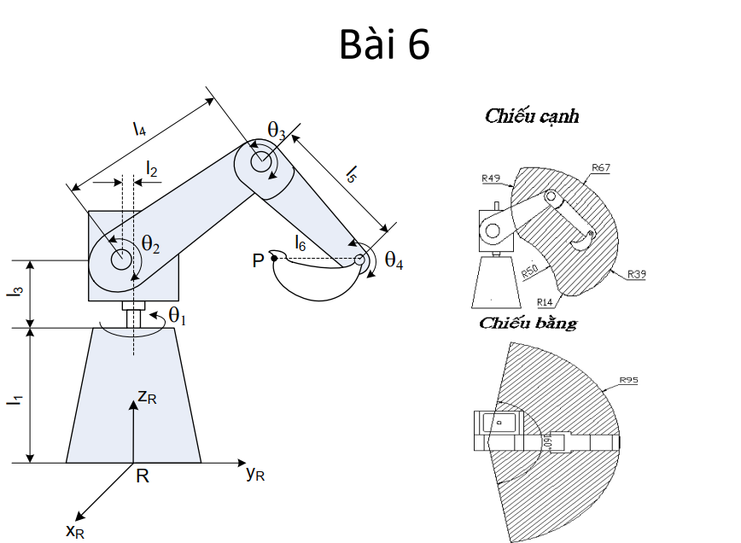

Mô tả: T(0,0,l1)R(z,t1)T(0,-l2,l3)R(x,t2)T(0,l4,0)R(x,t3)T(0,l5,0)R(x,t4)T(0,l6,0)

File đề: 

syms t1 t2 t3 t4 pi;

l1=60; l2=29; l3=15; l4=9; l5=10; l6=3;

for t1=0:0.1:pi

for t2=0:0.1:pi/2

for t3=0:0.1:pi/2

for t4=0:0.1:2\*pi

PX =-sin(t1)\*(l5\*cos(t2 + t3) - l2 + l4\*cos(t2) + l6\*cos(t2 + t3 + t4));

PY = cos(t1)\*(l5\*cos(t2 + t3) - l2 + l4\*cos(t2) + l6\*cos(t2 + t3 + t4));

PZ = l1 + l3 + l5\*sin(t2 + t3) + l4\*sin(t2) + l6\*sin(t2 + t3 + t4);

plot3(PX,PY,PZ,'\*');

hold on

end

end

end

end

Câu 7+9: 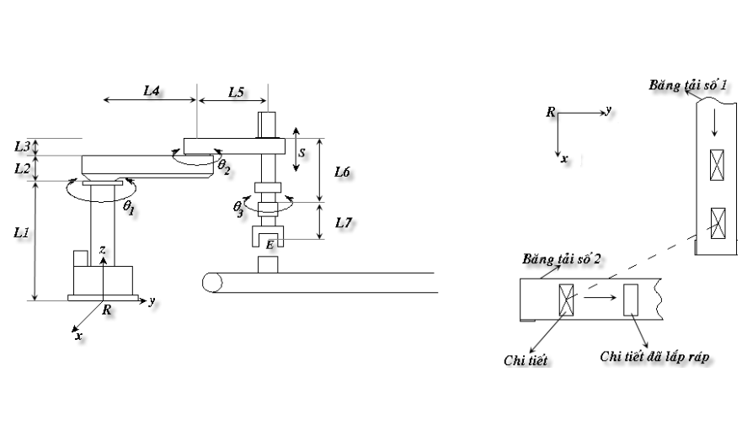

Mô tả: T(0,0,l1)P(z,θ1)T(0,l4,l2)P(z,θ1)T(0,l5,l3-l6+s)P(z,θ1)T(0,0,l7)

File:

syms t1 t2 pi;

l1=40; l2=70; l3=20; l4=56; l5=26; l6=9; l7=21; s=10;

for t1=0:0.1:pi/2

for t2=0:0.1:pi/2

Px = - l5\*sin(t1 + t2) - l4\*sin(t1);

Py = l5\*cos(t1 + t2) + l4\*cos(t1);

Pz = l1 + l2 + l3 - l6 - l7 + s;

plot3(Px,Py,Pz,'\*');

hold on

end

end

Câu 8: 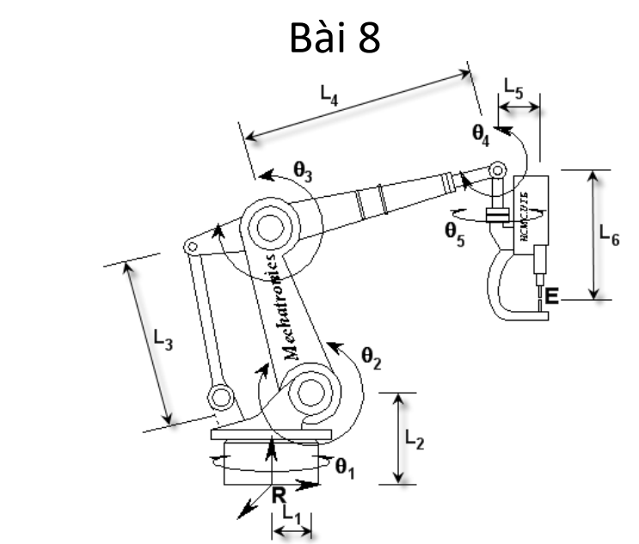

Mô tả:

R(z,t1)T(0,l1,l2)R(x,t2)T(0,0,l3)R(x,t3)T(0,l4,0)R(x,t4)T(0,l5,0)R(y,t5)T(0,l6-l5,l5)

File:

syms t1 t2 t3 t4 t5 pi;

l1=50; l2=60; l3=10; l4=60; l5=40; l6=30; l7=2;

for t1=0:0.1:pi

for t2=0:0.1:pi

for t3=0:0.1:pi/4

for t4=0:0.1:pi/4

for t5=0:0.1:pi

Px = l5\*(cos(t1)\*sin(t5) + sin(t2 + t3 + t4)\*cos(t5)\*sin(t1)) - l1\*sin(t1) - l4\*cos(t2 + t3)\*sin(t1) + l3\*sin(t1)\*sin(t2) - l5\*cos(t2 + t3 + t4)\*sin(t1) - l7\*cos(t2 + t3 + t4)\*sin(t1);

Py = l5\*(sin(t1)\*sin(t5) - sin(t2 + t3 + t4)\*cos(t1)\*cos(t5)) + l1\*cos(t1) + l4\*cos(t2 + t3)\*cos(t1) - l3\*cos(t1)\*sin(t2) + l5\*cos(t2 + t3 + t4)\*cos(t1) + l7\*cos(t2 + t3 + t4)\*cos(t1);

Pz = l2 + l5\*(cos(t2 + t3)\*sin(t4) + sin(t2 + t3)\*cos(t4)) + l7\*(cos(t2 + t3)\*sin(t4) + sin(t2 + t3)\*cos(t4)) + l4\*sin(t2 + t3) + l3\*cos(t2) - l5\*cos(t5)\*(sin(t2 + t3)\*sin(t4) - cos(t2 + t3)\*cos(t4));

plot3(Px,Py,Pz,'\*');

hold on

end

end

end

end

end

Câu 10: 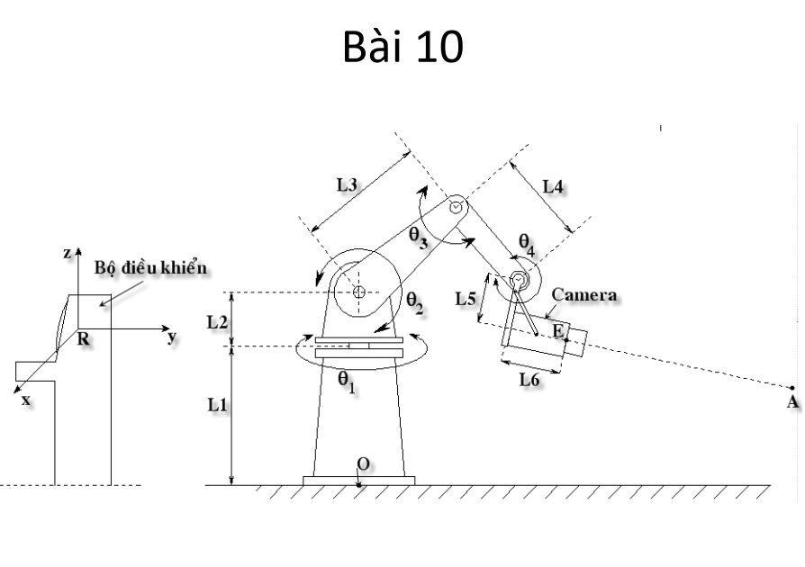  
Mô tả:T(0,0,l1)R(z,t1)T(0,0,l2)R(x,t2)T(0,l3,0)R(x,t3)T(0,l4,0)R(x,t4)T(0,l6,-l5)

File:

syms t1 t2 t3 t4 pi;

l1=12; l2=2; l3=9; l4=12; l5=15; l6=18;

for t1=0:0.1:pi

for t2=0:0.1:pi/2

for t3=0:0.1:pi/2

for t4=0:0.1:2\*pi

PX =-sin(t1)\*(l4\*cos(t2 + t3) + l3\*cos(t2) + l6\*cos(t2 + t3 + t4) + l5\*sin(t2 + t3 + t4));

PY =cos(t1)\*(l4\*cos(t2 + t3) + l3\*cos(t2) + l6\*cos(t2 + t3 + t4) + l5\*sin(t2 + t3 + t4));

PZ =l1 + l2 + l4\*sin(t2 + t3) + l3\*sin(t2) - l5\*cos(t2 + t3 + t4) + l6\*sin(t2 + t3 + t4);

plot3(PX,PY,PZ,'\*');

hold on

end

end

end

end